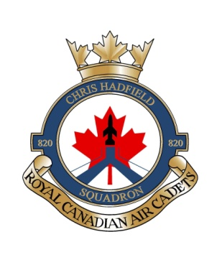

Sept 2022

A NOTE TO PARENTS AND CADETS – Annual Registration Fee

As part of the Air Cadet program, there is a civilian component called the Air Cadet League (ACL). It is the primary body of non-military volunteers that supports the overall cadet program, especially at the community level.

The Ontario Provincial Committee of the Air Cadet League is NOT government funded. It relies on community donations and fundraising to provide Air Cadets with additional resources including but not limited to:

- Guidance, oversight & training to the adult volunteers (including registration & screening);
- Administrative & other support to the local Squadron Sponsoring Committee (SSC);
- Optional training activities within the community and across the province;
- Scholarships, bursaries & awards for the cadets, adults and DND members ; and
- Infrastructure and activities far beyond the mandatory basic cadet program (for example airplane and glider maintainance).

Each Squadron Sponsoring Committee (made up of the local Air Cadet League volunteers) is assessed a fee by the provincial body that covers the financial requirements of both the provincial and national levels of the Air Cadet League. In Ontario, the OPC Annual Registration Fee for this year is $125.00 per cadet.

Individual squadrons may choose to cover this OPC Registration Fee in their local fundraising or may choose to pass this cost on to the parents. Regrettably, 820 Squadron cannot absorb this cost and needs to recover the registration fee in order to deliver our high quality program.

As such, each cadet will be charged a $200.00 Annual Registration Fee to cover the assessment fee, and other operating expenses (such as accommodations – the school and supply location alone costs 820 almost $20,000 per year in rental fees). We feel this is fair and reasonable considering the benefits derived from the Air Cadet program. When we consider the costs associated with costs of other extra-curricular activities in our community, our registration fees are affordable. A receipt will be issued. Payment is to be made in cash.

If you have any questions regarding this process, please contact your SSC Chairperson, Donald Alva at ssc.820squadron@gmail.com .

